Keywords

Wave overtopping, wave run-up, overtopping, run-up, WTI 2017, safety assessment, software, failure mechanism.

Summary

This document contains the requirements and functional design for a software kernel that computes the wave overtopping at dikes. This kernel will be referred to as the 'overtopping' kernel. This kernel eventually forms a part of the WTI 2017 failure mechanism library.

Samenvatting

Dit document bevat de eisen en het functioneel ontwerp voor een rekenkern waarmee golfoverslag bij dijken kan worden berekend. Deze rekenkern, waaraan gerefereerd als de overslagkern, zal deel uit maken van de bibliotheek van faalmechanismen van WTI2017.

References

KPP 2015 WK07 Waterveiligheidsinstrumentarium - VTV Tools.

|  |  |  |  |  |  |  |  |
| --- | --- | --- | --- | --- | --- | --- | --- |
| Version | Date | Author | Initials | Review | Initials | Approval | Initials |
| 1.0 | 2012 | B. Kuijper  M.T. Duits  R.G. Kamp |  | J.P. de Waal |  |  |  |
| 2.0 | aug. 2015 | J.P. de Waal |  | P. van Steeg |  | M. van Gent |  |
| 2.1 | sep. 2015 | J.P. de Waal |  | P. van Steeg |  | M. van Gent |  |
| 2.2 | apr. 2016 | E.J. Spee |  |  |  |  |  |

|  |
| --- |
| State  final |

Contents

1 Introduction 1

1.1 About this document 1

1.1.1 Purpose and scope of this document 1

1.1.2 Outline 1

1.1.3 The author(s) 2

1.1.4 Formula notation 2

1.2 Other system documents 2

2 Requirements 3

2.1 Assumptions and constraints 3

2.2 Functional requirements 3

3 General program structure 5

3.1 Input data 5

3.2 Output data 5

3.3 Program steps 5

3.4 Calculation steps for wave run-up and overtopping at a single cross section 6

4 Input parameters and their validation 9

4.1 Introduction 9

4.2 Load parameters: input and validation 9

4.3 Model factors: input and validation 9

4.4 Cross section data: input and validation 10

5 Wave run-up and overtopping formulas 13

5.1 Introduction 13

5.2 Functions related to wave run-up and overtopping for a single cross section 13

5.2.1 Calculate 2% wave run-up 13

5.2.2 Calculate representative slope angle 14

5.2.3 Assign fixed values to the constants in the run-up formula 15

5.2.4 Calculate intersection point breaking and non-breaking waves 15

5.2.5 Calculate influence factors angle of wave attack 16

5.2.6 Calculate influence factor roughness on slope 17

5.2.7 Calculate influence factor berms 18

5.2.8 Calculate influence factor one berm 19

5.2.9 Combine influence factors berms 21

5.2.10 Calculate adjustment of influence factors 22

5.2.11 Calculate wave overtopping discharge 24

5.3 Taking a foreshore into account 25

5.4 Combine computation results for cross sections 27

5.5 Calculate limit state function wave overtopping discharge 28

6 Load parameters: adjustments and derivatives 29

6.1 Adjustment to the wave conditions in case of shallow water 29

6.2 Calculate the wave length 29

6.3 Calculate the wave steepness 29

7 Cross section manipulations 31

7.1 Force a specified crest level 31

7.2 Merge two sequential berms 31

7.3 Split cross section for at least one wide berm 32

7.4 Force horizontal berms 34

7.5 Remove a horizontal berm 35

8 Notes 37

8.1 The 2% run-up height 37

8.2 The 'required crest level' 37

8.3 Wave overtopping percentages and volumes per wave 37

8.4 Intermediate slopes (between 1:15 and 1:8) 37

8.5 Intermediate results 37

8.6 Intermediate results for the 2% run-up height 38

8.7 Taking foreshores into account 38

8.8 Merging sequential berms with different roughness 38

8.9 The calculation procedure for wave overtopping in case of a wide berm 38

8.10 The calculation procedure in case of two wide berms 38

9 References 41

# Introduction

## About this document

### Purpose and scope of this document

This document contains the requirements and functional design for a software kernel that computes the wave overtopping at dikes. This kernel will be referred to as the 'overtopping' kernel. This kernel eventually forms a part of the WTI 2017 failure mechanism library.

Like all other failure mechanism modules, this module has two objectives:

* to be called in a deterministic environment, from a stand alone application such as RingToets
* to be called in a probabilistic environment such as Hydra-Ring.

The primary output of the overtopping module consists of:

* the 2% wave run-up height
* the mean wave overtopping discharge
* the value of the limit state function (z-function) for the wave overtopping discharge.

The computation of overflow is not included in this module: the z-function (as part of the output) explicitly pertains to the wave overtopping discharge only, i.e. for water levels that do not exceed the crest level. From tests with Hydra-Ring as a probabilistic environment, it was concluded that it is better to combine separate z-functions for wave overtopping and overflow within the probabilistic environment than to try and define a single z-function for both wave overtopping and overflow as a part of the failure mechanism module.

The document will not give any background on the context of the WTI project and on the derivation or motivation of the supported physical models. This Functional Design is based on two documents: [TAW, 2002] and [TDR, 2005]. The assumption is made that the contents of these two documents is correct. All relevant elements of these two documents for the overtopping module are described in the next chapters.

### Outline

Chapter 2 discusses the requirements. Chapter 3 gives the general program structure.

Since required computation steps and their order depend on the input characteristics, it was decided to describe the details of the computation steps in clusters of similar type in this document:

Chapter 4 describes the input parameters and their validation. Chapter 5 describes the computation method to calculate the wave run-up and wave overtopping discharge over the crest of a dike. Chapters 6 and 7 give general functions for manipulation on load parameters and cross section information respectively. Finally, in Chapter 8 some notes on the present computation method are given.

### The author(s)

Originally this document was written by B. Kuijper, M.T. Duits and R.G. Kamp, all from HKV consultants. Later the kernel structure was adjusted in order to better fit into the probabilistic program Hydra-Ring and some small adjustments to the functionalities were implemented. Moreover, a Deltares template for this type of documents evolved. The document was then adapted according to these developments by J.P. de Waal from Deltares.

### Formula notation

In some cases this document presents a formula that represents a (software) assignment, rather than an equation. In order to distinguish between these two types of formulae a different notation is used:

* "=" refers to an equation
* ":=" refers to an assignment

## Other system documents

The full documentation on the grass run-up kernel comprises the following documents.

|  |  |
| --- | --- |
| **Title** | **Content** |
| [Scientific background]  [TAW, 2002] and [TDR, 2005] | Scientific background of methods and rules |
| Requirements and functional design | This document |
| Technical Design | Definition of the different software components and their interaction |
| Programmers documentation | Description of the arguments and usage of different software components, generated from in-line comment with Doxygen |
| Test plan | Description of the different regression and acceptation tests, including target values. |
| Test report | Description of the test results. |

# Requirements

## Assumptions and constraints

1. As a general constraint, the development process needs to comply with the general process description for WTI software, contained in separate documents: (Knoeff and De Waal, 2014), (Brinkman, 2012) and for failure mechanism modules (Visschedijk and De Waal, 2013)..
2. As a general constraint, the kernel needs to comply with the relevant general requirements and further design rules for the programming, documentation and testing of WTI software. This set of requirements and rules is contained in a separate document (Brinkman, 2012). The set includes some of the constraints listed hereafter.
3. As a general WTI software constraint, the failure mechanism library will contain only components for a deterministic analysis to calculate a factor of safety or a limit state function (LSF, for probabilistic analysis), with a choice between different models for different (sub)mechanisms, that can be called separately. In case of different submechanisms, the limit state functions will be supplied only per submechanism. The combination of these submechanisms inside a certain probabilistic procedure is expected to be performed in the external software (notably the probabilistic core of Ringtoets, called Hydra-Ring).
4. As a general WTI software constraint, all model constants need to be adaptable outside the kernel, in order to allow for varying values during probabilistic analysis.
5. As a general WTI software constraint, the failure mechanism library needs to support at least all models that are prescribed for detailed assessment according to the VTV2017.

As a general WTI software constraint, the software interface (API) must allow usage from C# (Ringtoets), as well as from FORTRAN (Hydra-Ring), and MATLAB (test environment). The API should include a pointer to a feedback function for messages and warnings, with standardized interface.

## Functional requirements

This section describes the functional requirements for the overtopping module.

FR1 The overtopping module can be called from a stand-alone application such as Ringtoets.

FR2 The overtopping module can be called from a probabilistic environment such as Hydra-Ring.

FR3 The output of the FTO overtopping module is the 2% wave run-up, the overtopping discharge and the value for the limit state function for the wave overtopping discharge.

FR4 The computation of the 'hydraulic load level' (the required crest level to obtain a wave overtopping discharge exactly equal to the critical wave overtopping discharge) will not be included[1].

FR5 The check on good schematisation practice of the cross section needs to take place in the calling environment; it will not be performed in the overtopping module.

FR6 Horizontal berm sections are allowed.

FR7 At maximum two berms are allowed. These may be sequential.

FR8 Other boundary conditions for the dike profile stem from the ‘Hydra’s’ and are given in section 4.2.

FR9 The effect of vertical walls will not be included.

FR10 The kernel does not facilitate the calculation of the wave overtopping percentage and volumes per wave[2].

FR11 A computation for oblique, long crested waves will not be included.

FR12 Model parameters will be programmed as input parameters for the overtopping module.

FR13 The point of transition from breaking waves to non-breaking waves will be computed and not selected as a constant value of 1.8.

FR14 The computation should not exit with an error code. An error code is allowed in case of a physically impossible answer.

# General program structure

This chapter describes the input/output of the program and the program structure in general. More details (especially for the input data requirements and the calculation procedure) are given in the following chapters.

## Input data

The input for the overtopping module consists of:

* Load parameters
* Cross section data
* Model factors

The load parameters are the still water level and the wave parameters at the toe of the dike. Any reduction of the wave parameters due to the presence of a foreland has to take place before the wave parameters are given as input to the overtopping module. In other words: the calculation of the wave reduction through a foreland is not part of this program.

Since no foreland is used within the overtopping module, the cross section consists only of dike segments from the toe of the dike to the outer crest level. These segments are given by the (x,y) coordinates and have to satisfy certain boundary conditions (section 4.4). The roughness reduction factors for the different dike segments are also part of the input data, as is the outer normal (the orientation) of the dike, which is necessary to determine the angle of wave attack.

Finally some model factors (used in the calculation of the wave run-up and overtopping) are part of the input data of the module. See section 4.3 for more details.

## Output data

The output of the overtopping module consists of:

* Main results
* Error information
* Version information

The main results are the 2% wave run-up[3] (in m), the wave overtopping discharge (in m3 per m per s) and the value for the limit state function for the wave overtopping discharge[4]. The error information consists of a code (flag for success) and an error message (for failure).

## Program steps

The general program structure of the overtopping module consists of the following steps:

1. Check input:
   1. Load parameters [section 4.2].
   2. Model factors [section 4.3].
   3. Check input: cross section data [section 4.4].
2. If applicable, adjust the cross section so that the crest level of the cross section equals the input value for the crest level (which is given separately from the input cross section) [section 7.1].
3. If applicable, merge two sequential berms [section 7.2].
4. Calculate the influence factors for the angle of wave attack [section 5.2.5]
5. If applicable, adjust the wave parameters
   1. If applicable, adjust the wave parameters to account for very oblique wave attack [section 5.2.5].
   2. If applicable, adjust the wave parameters to account for shallow water [section 6.1].
6. If there is no wave attack (wave height zero or wave period zero),

then assign zero to 2% wave run-up (z2%) and wave overtopping discharge (q0)

go to step 10,

else proceed with step 7.

1. If the cross section contains at least one 'wide berm' then generate two cross sections, one in which all wide berms are adjusted to foreshores and one in which all wide berms are adjusted to ordinary berms [section 7.3].
2. For each cross section:

If the cross section does not contain a foreshore,

then calculate 2% wave run-up (z2%) and wave overtopping discharge (q0) [section 3.4],

else calculate 2% wave run-up (z2%) and wave overtopping discharge (q0), taking foreshores into account [section 5.3].

1. If applicable, combine results for wave run-up (z2%) and overtopping discharge (q0) for all cross sections [section 5.4].
2. Compute the value for the limit state function for the wave overtopping discharge [section 5.5].

## Calculation steps for wave run-up and overtopping at a single cross section

1. If applicable, adjust non-horizontal berms to horizontal berms [section 7.4].
2. Iterate until 2% wave run-up reaches an equilibrium:
   1. Estimate 2% wave run-up: z2% (if available, use result of former iteration step, otherwise assume z2% = 1.5 Hm0 as initial value)
   2. Calculate representative slope angle tan α [section 5.2.2].
   3. Calculate z2%,smooth, neglecting the effect of berms and roughness (assume γb=1 and γf=1) [section 5.2.1].
   4. Calculate influence factor roughness on slope: γf [section 5.2.6].
   5. Calculate z2%,rough, neglecting the effect of berms (assume γb = 1) [section 5.2.1].
   6. Calculate influence factor berms: γb [section 5.2.7].
   7. Calculate new influence factor roughness on slope: γf [section 5.2.6].
   8. If applicable, adjust the influence factors [section 5.2.10]
   9. Calculate 2% wave run-up: z2% [section 5.2.1].
3. Calculate wave overtopping discharge: qo [section 5.2.11].

**Remarks**

* Convergence of the iteration process (step 2) cannot be guaranteed. The stopping criterion will become a function of two subsequent iteration steps.
* Intermediate calculations of z2% (step 2c, 2e and 2i) will use the *input value* for the model factor for run-up mz2. See note in section 8.6.

# Input parameters and their validation

## Introduction

This chapter describes the input parameters for the overtopping module, including the cross section of the dike. The boundary conditions for these data are given, and also a description of the procedure to check the input data for the cross section. Finally, a procedure is given to make necessary adjustments to the cross section as a pre-processing step before the actual calculation of the wave run-up and overtopping.

## Load parameters: input and validation

The following model factors are required as input:

h (m+NAP) Still water level (i.e. local water level)

Hm0 (m) Significant wave height

Tm-1,0 (s) Spectral wave period

ϕ (°N) Wave direction

The module performs the following checks on the input data mentioned above:

* Still water level: h ≤ hcrest
* Significant wave height: Hm0 ≥ 0
* Spectral wave period: Tm-1,0 ≥ 0
* Wave direction: 0 ≤ ϕ ≤ 360

## Model factors: input and validation

The following model factors are required as input:

fb (-) Model factor for breaking waves (4.3 in [TAW, 2002], formula 22)

fn (-) Model factor for non-breaking waves (2.3 in [TAW, 2002], formula 23)

fshallow (-) Model factor for shallow water waves (parameter -C in [TAW, 2002], formula 27)

mz2 (-) Model factor describing the uncertainty of z2%; mz2>0

mqc (-) Model factor describing the uncertainty of qc; mqc>0

mqo (-) Model factor describing the uncertainty of qo; mqo>0

In earlier versions of this document and the implementation in code there were three model factors describing the uncertainty in the 2% wave run-up height z2%: frunup1, frunup2 and frunup3.

The role of model factor is now fulfilled by one single model factor: mz2. The parameters frunup1, frunup2 and frunup3 are still present in the formulas and code, but are set to a fixed value, which is based on their mean value as mentioned in [TAW, 2002], see section 5.2.3.

In a probabilistic environment, the uncertainty of q0 is usually described by considering the the model factors fb, fn and fshallow as stochastic variables and assigning a fixed value of 1.0 to mqo.

For the model factors mz2, fb, fn and fshallow distributions are given in [TAW, 2002]:

|  |  |  |  |  |  |
| --- | --- | --- | --- | --- | --- |
| parameter | Distr | μ | σ | σ/μ | design |
| mz2 | Normal | 1.00 | 0.07 | 0.07 | 1.07 |
| fb | Normal | 4.75 | 0.50 |  | 4.30 |
| fn | Normal | 2.60 | 0.35 |  | 2.30 |
| fshallow | Normal | 0.92 | 0.24 |  | 0.6778[5] |

Table 4.1 Distributions for model factors

## Cross section data: input and validation

For a cross section the following data is required as input:

ψ (°N) orientation of the dike normal

x (m) x-coordinates cross section (x1,..., xN)

y (m+NAP) y-coordinates cross section (y1,..., yN)

r (-) roughness factor dike segments (r1,..., rN-1)

hcrest (m+NAP) crest level (to be forced)

qc (m3/ms) critical value for the wave overtopping discharge per meter crest width

Note:

* (x1,y1) is the (outer) toe of the cross section
* (xN,yN) is the (outer) crest of the cross section

The module checks whether the input data mentioned above meets the following requirements:

* The number of x-coordinates equals the number of y-coordinates N; N≥2.
* The x-coordinates must increase: xi+1 > xi; actually: xi+1-xi ≥ 0.02 m
* The y-coordinates must be non-decreasing: yi+1 ≥ yi.
* Dike segments are either slope segments or berm segments:
  + Slope segments have a minimum gradient of 1:8 and a maximum of 1:1.
  + Berm segments have a maximum gradient of 1:15.
* A maximum of two berm segments is allowed.
* The first and the last dike segment has to be a slope segment (1:8 ≤ gradient ≤ 1:1).
* The number of roughness factors (in rdike) must equal the number of segments, that is: the number of (x,y)-coordinates minus 1; N-1.
* The roughness factors must lie between 0.5 and 1.0 ([TDR, 2005], section 6.2.1).
* Orientation of the dike normal: 0 ≤ ψ ≤ 360.
* The crest level to be forced must be higher than the toe: hcrest > y1
* The critical overtopping discharge must be larger than zero: qc > 0

Remarks:

Note that the definition of the orientation of the dike normal ψ as used in this module is closely related to the definition of the wave direction ϕ: in case of full wave attack on the dike, these parameters have the same value.

As a part of good schematisation practice, the minimum distance between x-coordinates should be about 2 m. However, this is not a part of the functional requirements pertaining to the overtopping module input and therefore the overtopping module will not verify this[6]. Such a verification may be part of the application that calls the overtopping.

Since the dike segments are either slope segments or berm segments (as defined above), segments with an inclination between 1:15 and 1:8 are not allowed. This is an important limitation of the program and deviates from the cross section boundary conditions for PC Overslag[7].

# Wave run-up and overtopping formulas

## Introduction

This chapter describes the functions required to calculate the wave run-up and wave overtopping discharge over the crest of a dike. The order of the sections does not reflect the order of the computation.

## Functions related to wave run-up and overtopping for a single cross section

### Calculate 2% wave run-up

**Input:**

Hm0 (m) Significant wave height

Tm-1,0 (s) Spectral wave period

tanα (-) representative slope angle

γβz (-) Influence factor angle of wave attack for wave run-up

γf (-) Influence factor roughness

γb (-) Influence factor berms

mz2 (-) Model factor describing the uncertainty of z2%

frunup1 (-) Constant 1 in wave run-up formula

frunup2 (-) Constant 2 in wave run-up formula

frunup3 (-) Constant 3 in wave run-up formula

**Output:**

so (-) Wave steepness

ξo (-) Breaker parameter

 (-) intersection point for breaking and non-breaking waves

z2% (m) 2% run-up height[8]

**Calculation:**

1. Calculate the wave steepness [section 6.3]
2. Calculate the breaker parameter ([TAW, 2002], formula 1, page 8):



1. Calculate the intersection point for breaking and non-breaking waves [section 5.2.4].
2. For small breaker parameter calculate the 2% wave run-up for breaking waves ([TAW, 2002], formula 3a, page 8), otherwise calculate 2% wave run-up for non-breaking waves ([TAW, 2002], formula 3b, page 9):



### Calculate representative slope angle

**Input:**

SWL (m+NAP) Still water level

Hm0 (m) Significant wave height

z2% (m) 2% run-up height

x (m) x-coordinates cross section containing only slope segments and at maximum two - horizontal - berm segments

y (m+NAP) y-coordinates cross section containing only slope segments and at maximum two - horizontal - berm segments

**Output:**

tanα (-) representative slope angle of cross section

**Calculation:**

The calculation of the representative slope is displayed in ([TAW, 2002], page 13). The representative slope angle is the average slope in the zone between SWL – 1.5 Hm0 and SWL + z2%. Berms must be disregarded in this calculation, so if applicable, all berms must be removed first [section 7.5].

The first time the representative slope angle is calculated, the 2% wave run-up is unknown. As initial value for the wave run-up z2% = 1.5 Hm0 is used.

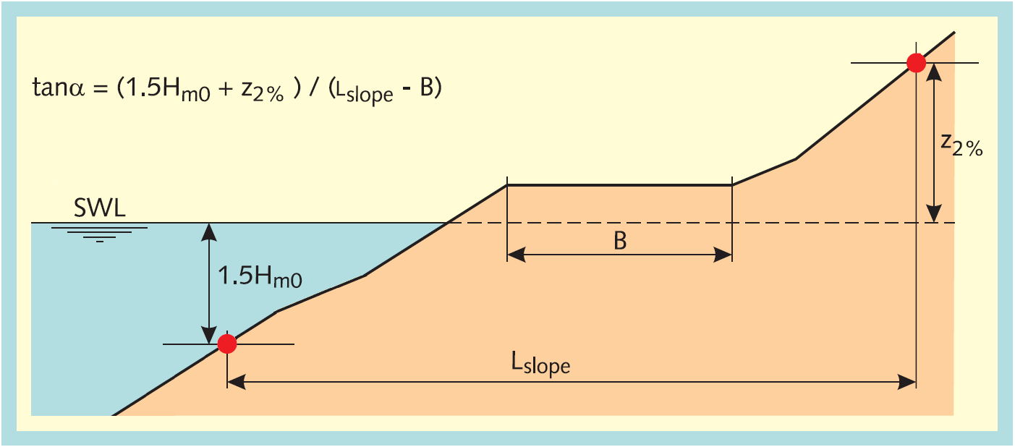

Figure 5.1 Calculation of the representative slope for a cross section with multiple sections

Because a cross section without berms is the input, the calculation of the representative slope angle uses the following steps:

1. Determine ylower:



1. Determine the corresponding xlower through interpolation using x and y
2. Determine yupper



1. Determine the corresponding xupper through interpolation using x and y
2. Calculate the representative slope angle:



### Assign fixed values to the constants in the run-up formula

The following values are assigned to the constants in the run-up formula:







These are the mean values for these constants as presented in [TAW, 2002], formula 5a and 5b, page 10. Note that the uncertainty in z2% is accounted for by the model factor mz2, which has a mean value of 1.00 and a standard deviation of 0.07.

### Calculate intersection point breaking and non-breaking waves

**Input:**

γb (-) Influence factor berms

frunup1 (-) Constant 1 in wave run-up formula

frunup2 (-) Constant 2 in wave run-up formula

frunup3 (-) Constant 3 in wave run-up formula

**Output:**

 (-) Intersection point for breaking and non-breaking waves

**Calculation:**

1. Solve the breaker parameter at the transition (ξ0t) in the equation



using cubic roots solver.

1. Choose in solutions for ξ0t the relevant intersection point see Figure 5.2.
2. If no solution is found, set ξ0t = 0.
3. Assess :





Figure 5.2 Wave run-up as function of breaker parameter

### Calculate influence factors angle of wave attack

**Input:**

ψ (°N) orientation of the dike normal

ϕ (°N) Wave direction

Hm0 (m) Significant wave height

Tm-1,0 (s) Spectral wave period

**Output:**

β (°) Angle of wave attack

γβz (-) Influence factor angle of wave attack for 2% wave run-up

γβo (-) Influence factor angle of wave attack for overtopping

γs (-) Wave adjustment parameter

Hm0 (m) (Adjusted) Significant wave height

Tm-1,0 (s) (Adjusted) Spectral wave period

**Calculation:**

1. Calculate the angle of wave attack:



1. Calculate the influence factor for the angle of wave attack for 2% wave run-up ([TAW, 2002], formula 8, page 16):



1. Calculate the influence factor for the angle of wave attack for overtopping ([TAW, 2002], formula 9, page 16):



1. Calculate the wave adjustment parameter ([TAW, 2002], page 16):



1. Adjust the wave parameters ([TAW, 2002], page 16):





### Calculate influence factor roughness on slope

**Input:**

x (m) x-coordinates cross section (x1,..., xN)

y (m+NAP) y-coordinates cross section (y1,..., yN)

r (-) roughness factor dike segments (r1,..., rN-1)

h (m+NAP) Still water level (i.e. local water level)

z2%,smooth (m) 2% run-up height without roughness

 (-) intersection point for breaking and non-breaking waves

γb (-) Influence factor berms

ξo (-) Breaker parameter

**Output:**

γ­f (-) Influence factor roughness

**Calculation:**

1. Determine ylower:



1. Determine yupper



1. Determine the roughness (r,i) and the length (Li) of the segments between ylower and yupper
2. Calculate the influence factor for the roughness ([TAW, 2002], formula 19, page 25):



1. Adjust the influence factor for large breaker parameter values ([TAW, 2002], page 20):



### Calculate influence factor berms

The permitted cross sections have a maximum of two berms. The computation of the influence of the berms is made with the calculation cross section with only horizontal berms with a maximal width of one-quarter of the wave length. The computation is made for each berm separately and afterwards the influences of the berms are combined.

**Input:**

x (m) x-coordinates cross section with horizontal berms and berm width is maximal one-quarter of the wave length

y (m+NAP) y-coordinates cross section with horizontal berms and berm width is maximal one-quarter of the wave length

**Output:**

γb (-) Influence factor berms

**Calculation:**

1. Calculate influence factor first berm [section 5.2.8]
   * if influence factor first berm equals 0.6 no further computations are needed:   
     total influence factor of all berms altogether is equal to 0.6.
   * if a second berm exists:   
     calculate influence factor second berm [section 5.2.8]
   * if influence factor second berm equals 0.6 no further computations are needed:   
     total influence factor of all berms altogether is equal to 0.6.
   * if applicable combine influence factors berms [section 5.2.9]
2. Calculate adjustment of influence factors [section 5.2.10]

### Calculate influence factor one berm

A berm in a cross section affects the wave run-up and the wave overtopping. The width of a berm is significant and also the position of the berm in relation to the still water line (SWL). The total influence of one berm is the combination of the influences of these two elements.

**Input:**

SWL (m+NAP) Still water level (i.e. local water level)

Hm0 (m) Significant wave height

z2%,rough (m) 2% run-up height with roughness

x (m) x-coordinates cross section with horizontal berms and berm width is maximal one-quarter of the wave length

y (m+NAP) y-coordinates cross section with horizontal berms and berm width is maximal one-quarter of the wave length

**Output:**

γb (-) Influence factor berm

B (m) Berm width

Lberm (m) Length of the cross section with influence of the berm

rdh (m) depth of the berm in relation to the water level

**Calculation:**

In wave run-up formulas, the influence of a berm is calculated with a berm factor, in which two influences are taken into account:

* the influence of the width of the berm in relation to the wave height and the shape of the cross section (parameter rb)
* depth of the berm in relation to the water level (parameter rdh).

1. Determine Lberm – the length of the cross section against which the length of the berm is deposed – through interpolation using x and y. shows the derivation method. Note that the still water line (SWL) isn't relevant for Lberm. Restrict Lberm by using the toe and crest of the cross section in the computation of Lberm:





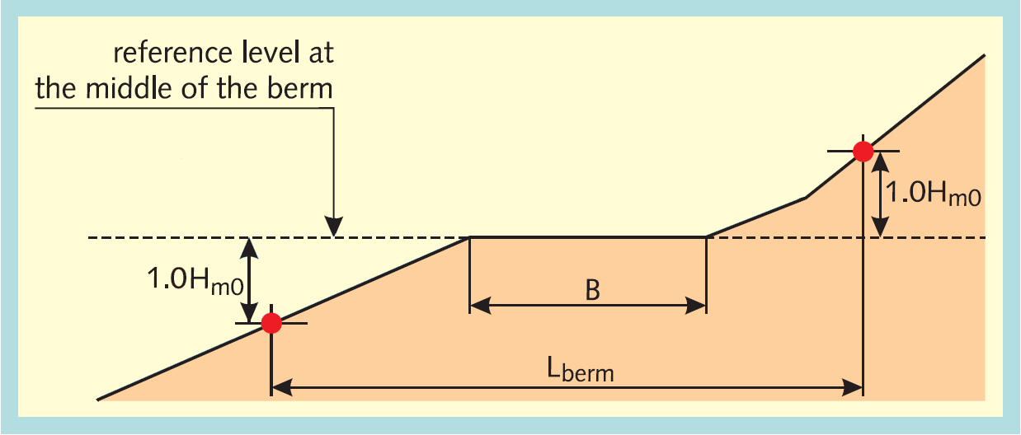

Figure 5.3 Computation of Lberm the length of the cross section against which the length of the berm is deposed

1. Calculate the influence of the width of the berm in relation to Lberm:



1. Calculate the difference between the berm height and the still water line:



1. Calculate the influence of the depth of the berm in relation to the still water line:



1. calculate;



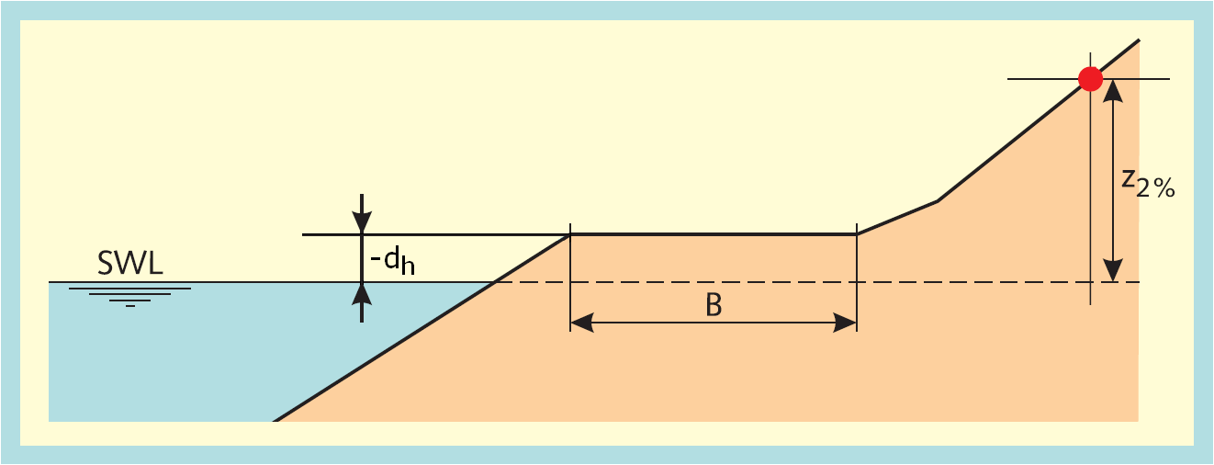

Figure 5.4 If the position of the berm is above the water level the parameter rdh is less than 1 (rdh < 1) as the difference of the berm height and the still water line is less than z2% (z2% > -dh)

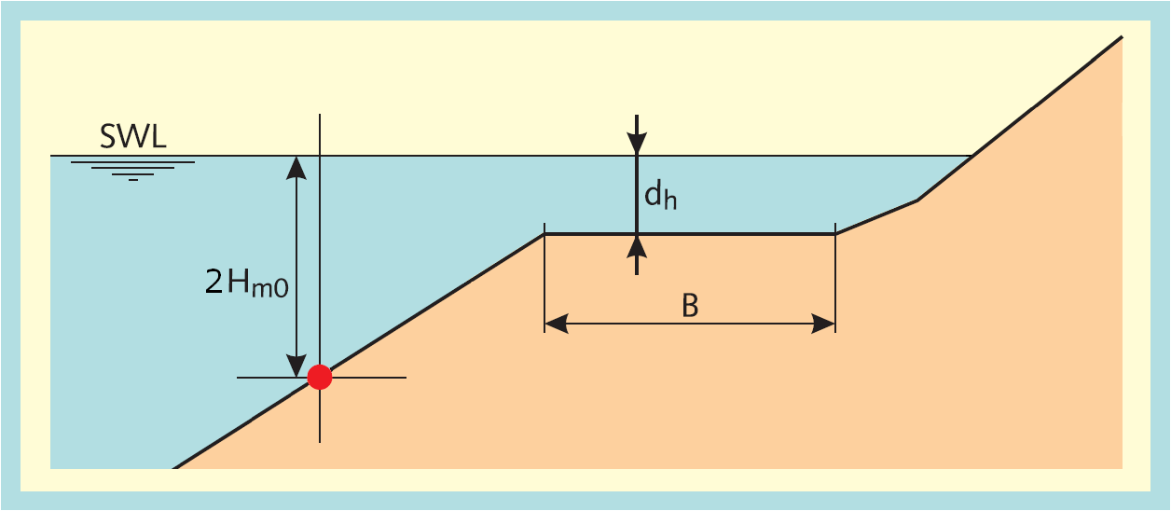

Figure 5.5 If the position of the berm is below the water level the parameter rdh is less than 1 (rdh < 1) as the difference of the berm height and the still water line is less than 2Hm0 (2Hm0 > dh)

### Combine influence factors berms

**Input:**

B (m) Berm widths (vector)

L (m) Length of the cross section with influence of the berm (vector)

rdh (m) depth of the berm in relation to the water level (vector)

**Output:**

γb (-) Influence factor berms

**Calculation:**

1. calculate for all berms i:



1. calculate for all berms i: f2(i)



1. calculate f3



1. calculate f4



1. calculate f5



1. calculate γb



N.B. The above formulas give in case of only one berm exactly the formula used for one berm.

### Calculate adjustment of influence factors

**Input:**

γb (-) Influence factor berms

γβ (-) Influence factor angle of wave attack (for 2% wave run-up or overtopping)

γ­f (-) Influence factor roughness

ξo (-) Breaker parameter

 (-) intersection point for breaking and non-breaking waves

**Output:**

γb (-) Influence factor berms

γβ (-) Influence factor angle of wave attack (for 2% wave run-up or overtopping)

γ­f (-) Influence factor roughness

**Calculation:**

A requirement of the influence factors (γb, γf, γβ) is that the product of these influence factors is not less than 0.4. In case it is less the minimum factor of 0.4 should be used for the product of the influence factors ([TAW, 2002], formula 6, page 12). For some calculation steps in the computations of the wave run-up (paragraph **Error! Reference source not found.**) and in the computations of the wave overtopping (paragraph **Error! Reference source not found.**) the total influence factor is used and for other steps the individual influence factors are used. In order to use consistent influence factors, all the influence factors are adapted if the total influence factor is less than 0.4. The adjustment ensures that the product of the influence factors is equal to 0.4. The adjustment of the influence is only calculated if the product of the influence factors is less than 0.4.

1. Calculate the total influence factor



1. Calculate the ratio for the influence factor of roughness in relation to the minimum influence factor of roughness,



where γf,min = 0.55 ([TDR, 2005], page 26 and 28).

1. Calculate the ratio for the influence factor of berms in relation to the minimum for influence factor of berms



where γb,min = 0.6 ([TDR, 2005], page 26 and 28).

1. Calculate the ratio for the influence factor of wave attack in relation to the minimum for influence factor of wave attack:



where γβ,min = 0.824 for 2% wave run-up ([TDR, 2005], page 26) and γβ,min =0.736 for wave overtopping ([TDR, 2005], page 28).

1. Calculate the sum of the ratios:



1. Adapt the influence factors:







### Calculate wave overtopping discharge

**Input:**

y (m+NAP) y-coordinates cross section (y1,..., yN)

h (m+NAP) Still water level (i.e. local water level)

Hm0 (m) Significant wave height

tanα (-) representative slope angle

γβo (-) Influence factor angle of wave attack for overtopping

γb (-) Influence factor berms

γ­f (-) Influence factor roughness

fb (-) Model factor for breaking waves (4.3 in [TAW, 2002], formula 22)

fn (-) Model factor for non-breaking waves (2.3 in [TAW, 2002], formula 23)

fshallow (-) Model factor for shallow water waves (parameter -C in [TAW, 2002], formula 27)

ξo (-) Breaker parameter

g (m/s2) acceleration due to gravity

**Output:**

qo (m3/m/s) overtopping discharge

**Calculation:**

1. Calculate adjustment of influence factors [section 5.2.10]
2. If the breaker parameter ξ0 ≤ 5, calculate the dimensionless overtopping discharge for breaking waves ([TAW, 2002], formula 22, page 26):



1. If the breaker parameter ξ0 < 7, calculate the dimensionless overtopping discharge for non-breaking waves ([TAW, 2002], formula 23, page 26):



1. If the breaker parameter ξ0 > 5, calculate the dimensionless overtopping discharge for shallow water ([TAW, 2002], formula 26, page 31):



with:



1. Calculate the overtopping discharge:

* ([TAW, 2002], formulae 22 & 23, page 26):



* ([TAW, 2002], page 31):



* ([TAW, 2002], formula 26, page 31):



## Taking a foreshore into account[9]

A cross section contains a foreshore if the length of a berm segment (the gradient of the segment has a maximum of 1:15) is at least one wave length (L0). If the cross section contains a foreshore there are three possibilities for the still water line (SWL):

1. The still water line is below the foreshore:
   * Adjust non-horizontal foreshores to horizontal foreshores (like a berm) [section 7.4]
   * The wave overtopping discharge is set equal to 0.
   * For the computation of the 2% wave run-up (z2%) use the calculation steps in [section 3.4]. The difference between the water level h and the height of the horizontal foreshore is the maximum of the 2% wave run-up.
2. The still water line is on the foreshore:
   * The 2% wave run-up (z2%) is equal to 0.
   * The wave overtopping discharge is equal to 0.
3. The still water line is above the foreshore:
   * The cross section is adjusted by removing the foreshore and all segments below the foreshore. The inner point of the foreshore in the original profile becomes the toe of the new profile.
   * The wave height is adjusted on the basis of the new toe level (y1), using



Where:

fred (-) Wave height reduction factor, representing the maximum ratio of wave height to water depth; 0.3 ≤ fred ≤ 1.0; (-)

Note that fred is an input factor for the kernel, usually set at 0.5.

* + No adjustments are made to the wave period Tm-1,0 and the wave direction ϕ.
  + Start computation method in section 3.4 after the above adjustments.

Note the differences in the approach of a *completely* new cross section, where wave conditions may be reduced in case of very oblique wave attack and where fred is implicitly set at the estimated upper limit of 1.0, see [section 6.1].

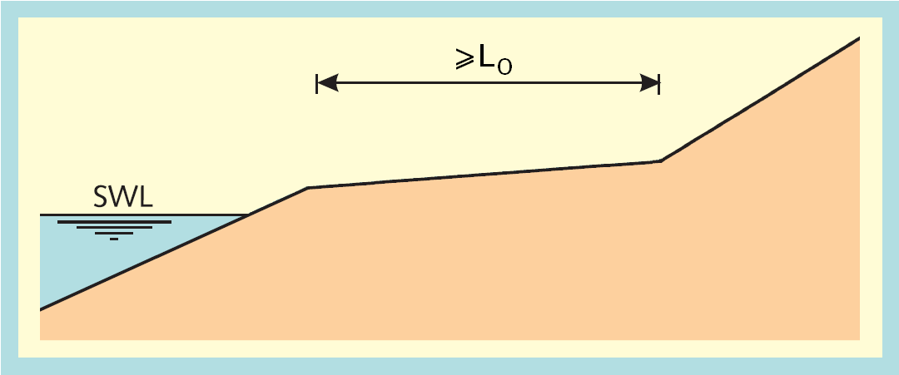

Figure 5.6 Still water line (SWL) below the foreshore

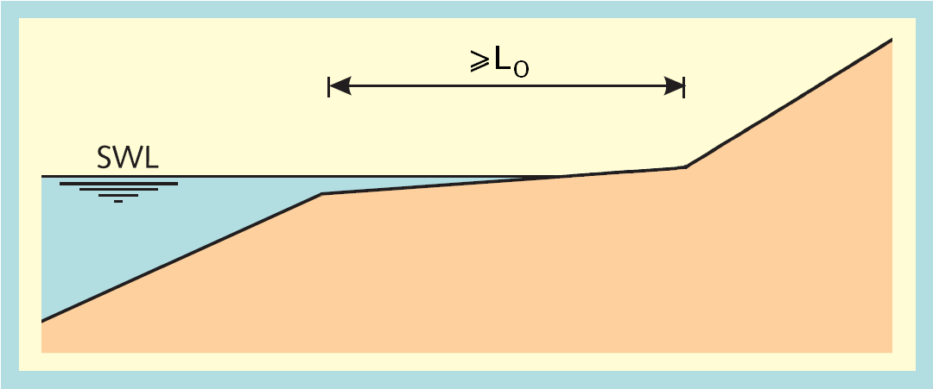

Figure 5.7 Still water line (SWL) on the foreshore

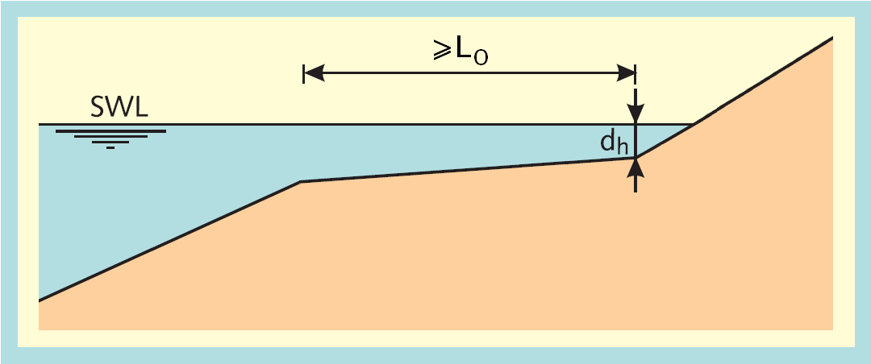

Figure 5.8 Still water line (SWL) above the foreshore

## Combine computation results for cross sections

If the original cross section – i.e. the cross section chosen by the user – includes at least one wide berm, then this cross section is split into two cross sections. For both cross sections a separate computation is made. The results of these two computations have to be combined ([TDR, 2005], section 7.8).

**Input:**

z2%,B (m) 2% wave run-up height of cross section without any wide berm, but with at least one berm

z2%,F (m) 2% wave run-up height of cross section without any wide berm, but with at least one foreshore

qo,B (m3/m/s) wave overtopping discharge per meter crest width of cross section without any wide berm, but with at least one berm

qo,F (m3/m/s) wave overtopping discharge per meter crest width of cross section without any wide berm, but with at least one foreshore

Nb (-) Number of wide berms

B (m) Array of berm widths of wide berms

L0 (m) wave length

**Output:**

z2% (m) 2% run-up height

qo (m3/m/s) overtopping discharge

**Calculation[10]:**





## Calculate limit state function wave overtopping discharge

**Input:**

qo (m3/m/s) wave overtopping discharge per meter crest width

qc (m3/m/s) critical value for the wave overtopping discharge per meter crest width

mqc (-) model factor describing the uncertainty of qc

mqo (-) model factor describing the uncertainty of qo

**Output:**

Z (-) limit state for wave overtopping discharge

**Calculation:**



Where

qo,min (m3/m/s) Minimum value for the computed wave overtopping discharge, introduced in order to avoid computing log(0). It is set equal to the smallest positive (non zero) number, within the accuracy settings of the kernel.

# Load parameters: adjustments and derivatives

## Adjustment to the wave conditions in case of shallow water

The toe is considered to be the end of a foreshore. The wave height at the toe is limited to the water depth above the toe, which is regarded as pragmatic upper limit for the wave height at the end of any foreshore:



Note that the wave height is set to zero for water levels below the toe.

## Calculate the wave length



Where

L0 (m) (Deep water) wave length

## Calculate the wave steepness



Where

so (-) Wave steepness

# Cross section manipulations

## Force a specified crest level

If the crest level to be forced (hcrest) is lower than the profile crest (yN), then the profile is cut off at the point on the profile where y = hcrest. Otherwise, the final profile segment is extended to hcrest (maintaining the slope and roughness).

## Merge two sequential berms

Merging two sequential berms is simply the replacement of these two berms by one new berm: the compound of the two berms. This is illustrated in Figure 7.1. For the (x,y)-coordinates of the cross section the replacement of the berms means removing one point (xi,yi) of this cross section. The roughness of the compound berm is a weighted average, based on the respective widths.

**Input:**

x (m) x-coordinates cross section with sequential berm segments

y (m+NAP) y-coordinates cross section with sequential berm segments

r (-) roughness factor dike segments with sequential berm segments

**Output:**

x (m) x-coordinates cross section without sequential berm segments

y (m+NAP) y-coordinates cross section without sequential berm segments

r (-) roughness factor dike segments without sequential berm segments

**Calculation:**

1. Assuming the dike segments i-1 and i are both a berm segment, the point (xi, yi) is removed from the cross section
2. Calculate the influence factor for the roughness of the compound berm segment ([TAW, 2002], formula 20, page 25)[11]:

In formulas:





First adapt ri-1:



Then adapt the arrays (remove point i):











Figure 7.1 Merging two sequential berm segments

## Split cross section for at least one wide berm

A cross section contains a wide berm if the berm width is between one-quarter of the wave length and one wave length. The wave length is equal to the squared wave period multiplied by a constant. For small wave periods the wave length is also small and berms can easily be larger than one-quarter of the wave length. If the cross section contains at least one wide berm split the cross section into two different cross sections. The procedure to split the cross section is shown in Figure 7.2. If the cross section contains more than one wide berm, all are split with the procedure shown in Figure 7.2 and it gives two cross sections: one in which the width of the wide berms is reduced to one-quarter of the wave length (thus becoming an ordinary berm) and one cross section in which the width of the wide berms is increased to one wave length (thus becoming a foreshore)[12].

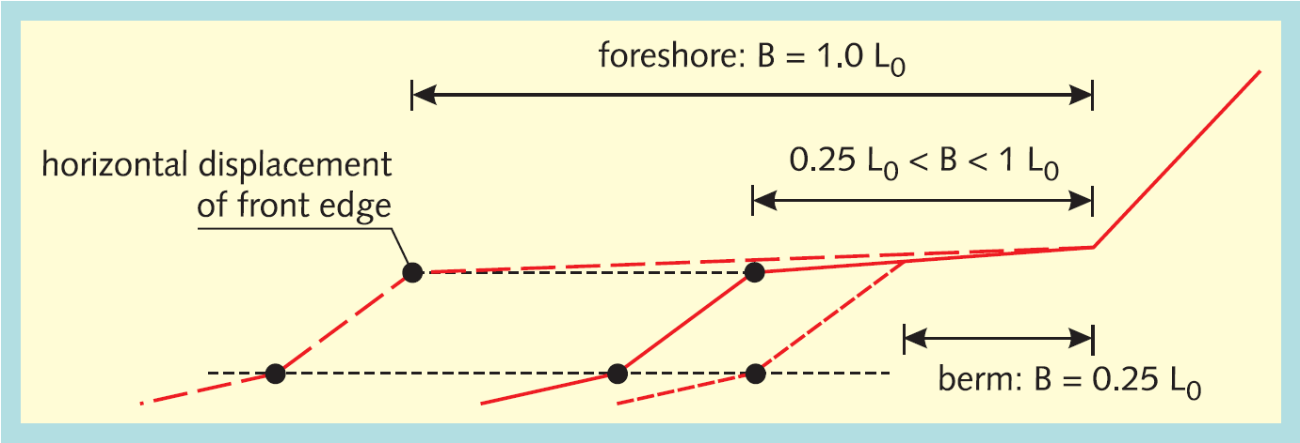

Figure 7.2 Procedure to split a cross section with a wide berm into two separate cross sections

**Input:**

Tm-1,0 (s) spectral wave period

x (m) x-coordinates cross section with at least wide berm

y (m+NAP) y-coordinates cross section with at least wide berm (y1,..., yN)

**Global constants:**

g (m/s2) acceleration due to gravity

**Output:**

xB (m) x-coordinates cross section in which the width of all wide berms is reduced to the maximum width of an ordinary berm.

yB (m+NAP) y-coordinates cross section in which the width of all wide berms is reduced to the maximum width of an ordinary berm

xF (m) x-coordinates cross section in which the width of all wide berms is increased to the minimum width of a foreshore

yF (m+NAP) y-coordinates cross section in which the width of all wide berms is increased to the minimum width of a foreshore

L0 (m) Wave length

Nb (-) Number of wide berms

**Calculation:**

1. Calculate the wave length L0 [section 6.2]
2. Determine the number of wide berms (Nb)
3. Determine the cross section with the berm (xB, yB) through interpolation using x and y. Figure 7.2 gives the derivation method.
4. Determine the cross section with the foreshore (xF, yF) through interpolation using x and y. Figure 7.2 gives the derivation method.

## Force horizontal berms

The influence factor of berms is computed with cross sections with horizontal berms. So, in addition to the cross section with non-horizontal berms, a calculation cross section with just horizontal berms is derived from the original cross section. The derivation is shown in Figure 7.3 for one berm. Each berm is treated in this way. The computation of the wave run-up and wave overtopping discharge is performed in an iteration process (section 3.4). In this process the calculation cross section with just horizontal berms is used, but it isn't necessary to compute it in each iteration step. So this computation is done only once. It is done before the iteration process.

**Input:**

x (m) x-coordinates cross section with non-horizontal berms

y (m+NAP) y-coordinates cross section with non-horizontal berms

**Output:**

xnew (m) x-coordinates cross section with horizontal berms

ynew (m+NAP) y-coordinates cross section with horizontal berms

**Calculation:**

1. Assess the middle of the berm:





1. Calculate the lower slope:



1. Calculate the upper slope:



1. Calculate the starting point of the horizontal berm:



or, alternatively:





1. Calculate the end point of the horizontal berm:





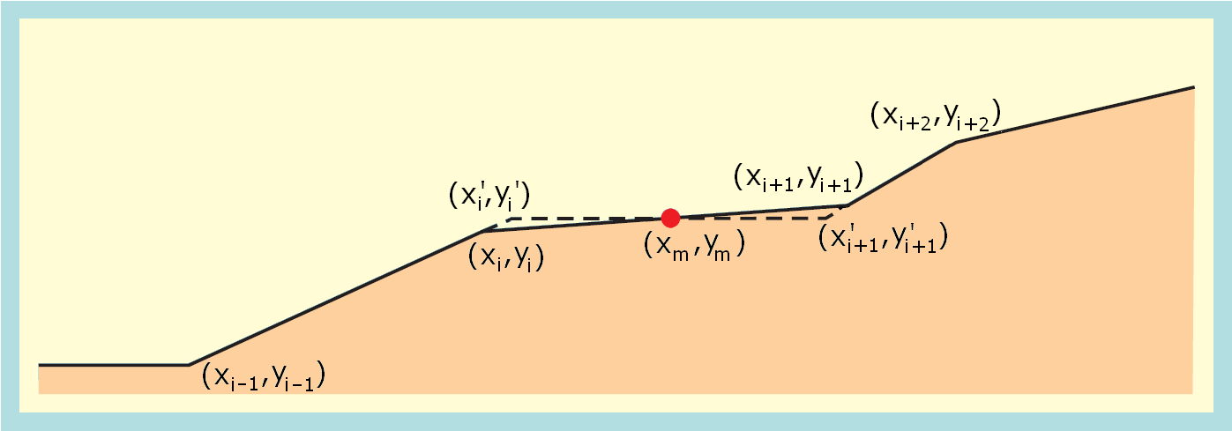

Figure 7.3 Adjustment of a non-horizontal berm

## Remove a horizontal berm

A horizontal berm is removed from a cross section by removing the inner end point of the berm and shifting all profile points higher than the berm horizontally outward, over a distance equal to the width of the horizontal berm.

# Notes

## The 2% run-up height

The 2% run-up height (as part as the output and as part of internal computations of this kernel) is not limited by the freeboard (i.e. crest level minus water level). This implies that 2% run-up level (i.e. the sum of water level and calculated 2% run-up height) may exceed the crest level. Although this is physically not realistic, no error or warning message will be generated by the kernel. Any check, limitation or message generation on this issue needs to be performed outside the kernel as part of the post-processing.

## The 'required crest level'

The kernel does not facilitate the calculation of a 'hydraulic load level' (the required crest level to obtain a wave overtopping discharge exactly equal to the critical wave overtopping discharge). However, it is estimated to be relatively easy to add such a (useful!) procedure to the dll functionalities in the future.

## Wave overtopping percentages and volumes per wave

The kernel does not facilitate the calculation of the wave overtopping percentage and volumes per wave. In order to replace the present PCoverslag (stand alone) software this option should be included in this kernel in the near future.

## Intermediate slopes (between 1:15 and 1:8)

The calculation method for an intermediate slope is not included yet. This method is not complicated and may be implemented in the future, if the restrictions to the segments within a cross section are reformulated to:

"Within a cross section at maximum two segments having a slope milder than 1:8 are allowed. At maximum one segment having a slope between 1:8 and 1:15 is allowed."

This reformulation does not extend the area of application of the kernel very much. On the other hand, introducing more flexibility will make the calculation method very complicated.

## Intermediate results

Initially, it was considered useful that the kernel would provide intermediate calculation results like the parameters tanα, ξo, γβz, γβo, γf, γb, etc. However, within a single calculation these parameters may get different values, for different stages within the calculation. It would require much additional administration to present those values with the actual context, in order to make this information useful. Monitoring the calculation process would be facilitated in debug mode anyway (though for programmers only). Therefore, it was decided not to add the required administration and to refrain from providing intermediate results.

## Intermediate results for the 2% run-up height

Several parameters (like tanα, γf and γb) require 'the' value of z2%. For the computation of z2% within that context [TAW, 2002] explicitly refers to the formula for the *design* values of z2%. This would imply that *within this context* the value of the model factor for wave run-up mz2 should be set at 1.07, instead of using the input value for mz2.

Somehow, it seems more appropriate to apply the *mean* value of z2% (mz2=1.00) for all computations of z2% and to apply the input value for the model factor in determining the final output value for z2% only. However, that would yield results that differ from those in [TAW, 2002].

In this application it is decided to use the input values for mz2. in all computations of z2%.

## Taking foreshores into account

The computation method to account for foreshores (section 5.3) is likely to yield discontinuities for a gradually increasing water level and a sloping foreshore. For water levels below the foreshore, the foreshore should not be adjusted to horizontal and the 2% run-up should be limited to the height of the outer point of the foreshore with respect to the water level.

## Merging sequential berms with different roughness

Taking the weighted mean roughness in case of merging two sequential (sloping) berms with different roughness implies a change in the distribution of roughness over the vertical levels along the cross section. This procedure may therefore be in conflict with the rule that roughness should only be taken into account within a specific range around still water level.

## The calculation procedure for wave overtopping in case of a wide berm

In this procedure, the same method is applied for both wave run-up and the wave overtopping discharge. Actually, in [TAW, 2002] section 3.3, a different (more complicated) method is presented for the wave overtopping discharge.

## The calculation procedure in case of two wide berms

In case of two wide berms the computation is subdivided into separate computations for two adjusted cross sections:

* lower wide berm adjusted to ordinary berm; upper wide berm adjusted to ordinary berm;
* lower wide berm adjusted to foreshore; upper wide berm adjusted to foreshore;

(And the overall result is the weighted average).

However, it may actually be more accurate (or plausible) to subdivide the computation into separate computations for four cross sections:

* lower wide berm adjusted to ordinary berm; upper wide berm adjusted to ordinary berm;
* lower wide berm adjusted to ordinary berm; upper wide berm adjusted to foreshore;
* lower wide berm adjusted to foreshore; upper wide berm adjusted to ordinary berm;
* lower wide berm adjusted to foreshore; upper wide berm adjusted to foreshore;

(And the overall result is the weighted average).

## Omkeervariant

The main purpose of the so called ‘omkeervariant’ is to get a minimal dike height with a given discharge, profile and load.

This dike height is calculated by repeatedly calculating the overtopping discharge and varying the dike height until the given discharge is found. By using the logarithmic relation between the discharge and the dike height, a very low number of iterations is necessary.

However, there are a few extra rules that must be met:

* The search for dike heights ranges from the dike toe until infinity.
* The given discharge must be greater than zero (although it may be very small, say 1E-20). There is no upper limit on the discharge, but if it is larger than the discharge for dike height equals water level, then the water level is returned.
* If the resulting dike height lies on a berm, a special procedure will be used: calculate the discharge on the neighbouring slope segments (above and below) and use logarithmic interpolation to get dike height on the berm. The dike height on the section above is the dike height of beginning of the section + 2 cm * the slope of the section. The dike height on the section below is the dike height at the end of the section, but at least 10 cm below the dike height used in the section above.
* If the water level is below the dike toe, the water level is returned as minimal dike height.

# References

[Brinkman, 2012]

RTO design. Deltares draft report 1206004-004, 2012.

[Duits en Kuijper, 2012]

Hydra-Zoet – Gebruikershandleiding – Versie 1.6 [HKV-rapport PR1564]. M.T. Duits en B. Kuijper. HKV LIJN IN WATER. Lelystad, juli 2012.

[Knoeff and De Waal, 2014]

Uitgangspunten WTI 2017. Deltares rapport 1209429-001-GEO-0011, 17 oktober 2014.

[TAW, 2002]

Technisch Rapport Golfoploop en Golfoverslag bij Dijken. J.W. van der Meer. Technische Adviescommissie voor de Waterkeringen (TAW). Delft, mei 2002.

[TDR, 2005]

Technisch definitierapport PC-Overslag, bijgewerkt tot en met juni 2005.

[Visschedijk and De Waal, 2013]

Versterking samenhang VTV instrumentarium. Op weg naar een nieuwe generatie dijksterkte software. Deltares concept rapport 1206005-002-HYE-0003, februari 2013.

1. See note in section 8.2.
2. See note in section 8.3.
3. See note in section 8.1
4. See note in section 8.5.
5. This value is based on the fact that 10C in [TAW, 2002] formula 27 is equal to 0.21 in design applications [TAW, 2002] formula 26.
6. Instead, the module does verify the far more relaxed requirement of a minimum distance of 2 cm, which seems appropriate for a robust computation of the segment gradient.
7. See note in section 8.4.
8. See note in section 8.1.
9. See note in section 8.7.
10. See the notes in section 8.9 and 8.10.
11. See the note in section 8.8.
12. See note in section 8.10.